
Mainline Computer Products Application Designer provided extensive design services to the customer along with many "proof of concept" builds.

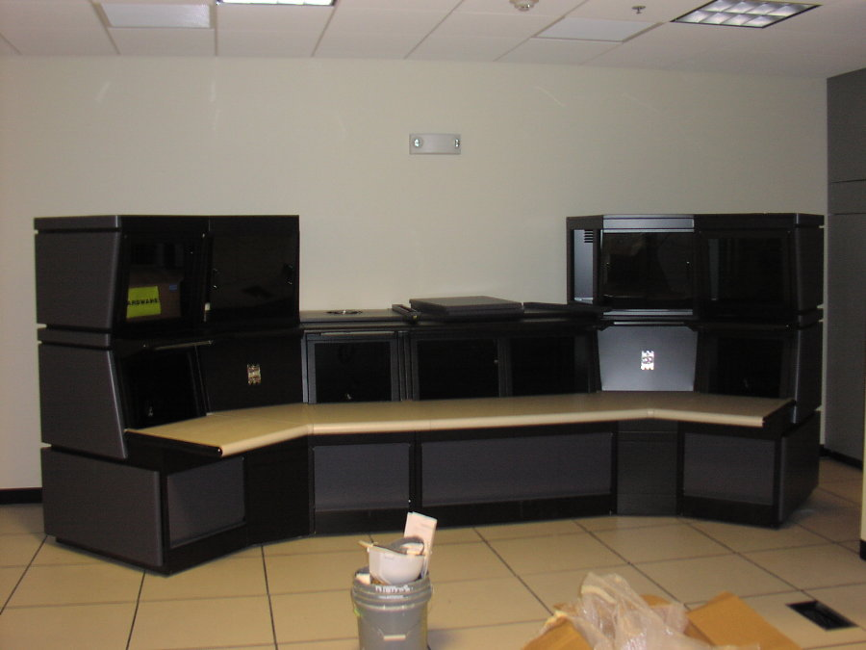
About the customer:
The mission of this customer is to provide retirement benefits, disability benefits, survivor benefits, and to administer health care programs in their particular Employee Retirement System.

About the application:

The product solution is a Command Console for an Enterprise Data Center Computer Operation where multiple consoles must be monitored 24x7x365.

Customer Product Specification:
• Required a console that would allow future growth
• Solid steel construction
• Large Work Surfaces for operators
• Ability to handle multiple monitor sizes

Solution

The SMC System 2000 Command Console~ This customer also purchases a sister product to the System
2000 Command Console, the S/2000 Flat Screen Console for their Network Operation Center.

